NASA ELaNa-19

On December 16th 2018, Electron, This One’s for Pickering, launched from Launch Complex 1 off of the Mahia Peninsula from New Zealand (NASA ELaNa-19,1). In a partnership between the National Aeronautics and Space Administration and Rocket Lab, this mission marked the beginning of dedicated commercial launch vehicles for CubeSats. ELaNa, or Educational Launch of Nanosatellites is a program created by NASA to draw the attention of students in science, technology, engineering and mathematics. ELaNa-19 was the 21st ELaNa mission by launch date and incorporated ten 3U CubeSats made by high schools and universities, as well as NASA field centers (Educational Launch of Nanosatellites,3).

On board This One’s for Pickering, sat CHOMPTT, RSat, DaVinci, CeREs, STF-1, NMTSat, ISX, CubeSail, ALBus, and Shields-1 (Educational Launch of Nanosatellites,1). These 10 CubeSats enjoyed a dedicated ride service, meaning that they were the primary objective of that launch mission. This dedication comes from the Venture Class Launch Services Contracts, with “The intention of the VLCS contracts is to provide alternatives to the current rideshare-type approach for launch of small satellites” (Educational Launch of Nanosatellites,3). In typical launch service operations, CubeSats were relegated to being ride-shares, meaning that they were subjected to the altitude and orbit of the primary objective. This hitchhiking lead to limitations in the scientific research each CubeSat could perform.

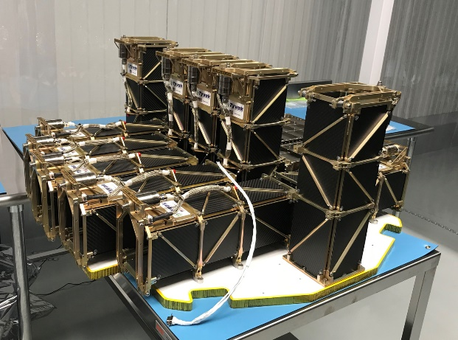

Figure Rocket Lab Kick stage Sat

NMTSat was built by undergrad and graduate students at New Mexico Tech in Albuquerque New Mexico. NMTSat operates with “primary goals to monitor space weather in low Earth orbit and correlate this data with results from structural and electrical health monitoring systems.” (Gunter's Space Page ,4). Use of instruments such as the Langmuir plasma probe and structural electrical systems study the Earth’s magnetic field and take atmospheric weather measurements. NMTSat is also New Mexico Tech’s first nano-sat constructed as a 3U CubeSat almost entirely by students.

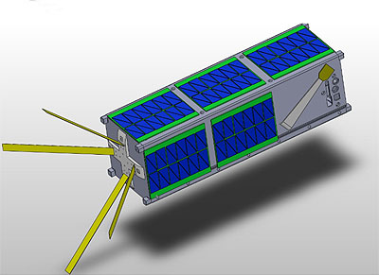

Figure NMTSat [NASA]

ISX CubeSat operates to look at plasma fluctuations in the upper atmosphere and to learn about their interactions with radio communications with satellites. It studies these “effects by measuring and comparing digital TV signals produced on the ground”, in particular the physics of naturally occurring Equatorial Spread of ionospheric irregularities. ISX or Ionospheric Scintillation Explorer is a collaboration between SRI International and PolySat at Cal Poly in San Luis Obispo California (Gunter's Space Page,4).

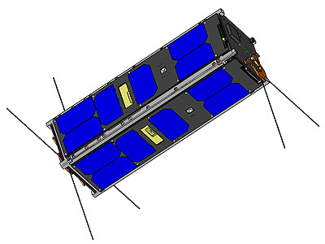

Figure ISX (CP 11) [Calpoly]

STF-1 is a collaboration between West Virginia Space Grants Consortium and West Virginia University. This CubeSat has two primary mission objectives, to monitor space weather over the pole, as well as to test new materials in LEDS. The monitoring of space weather over the North and South pole will increase the accuracy of navigation for CubeSats. The team at West Virginia also hopes to use test the durability of III-V Nitride Based Materials for shielding against radiation and extreme temperature variations in space (Gunter's Space Page,4).

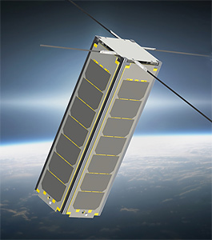

Figure STF 1 [NASA]

DaVinci was developed by North Idaho STEM Charter Academy, this CubeSat was designed with amateur radio to broadcast educational messages in Morse code. On board there also sits a GlobalStar modem and Arducam, which allows students to see photos of Earth from orbit and upload digital messages (Gunter's Space Page,4) . DaVinci has the capability to relay messages with any receiver kits that are tuned to the correct frequency, making it available to students globally.

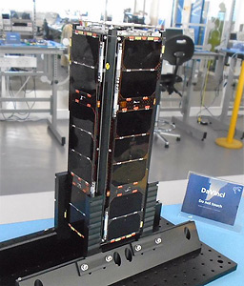

Figure Da Vinci [Project Da Vinci]

RSat was developed by midshipmen at the U.S. Naval Academy in Annapolis Maryland. This CubeSat operates with the intent to attach to a host satellite, maneuver around it to observe or repair the satellite. It does so by using crab-like dynamic motion to attach and position itself on satellites that may not be working properly or as intended. RSat demonstrates the viability of low cost, in-orbit mobile platforms and consists of two amateur radios, three TTL serial cameras, and four Arduino microprocessors (Gunter's Space Page,4).

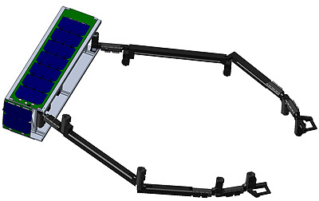

Figure RSat-P [USNA]

Sheilds-1 was produced by NASA Langley Research Center in Hampton Virginia. Sheilds-1 incorporated three technology demonstrations for the environmental durability of space hardware. This hardware would later to go on to “increase the technology readiness level of new commercial hardware through performance validation in the relevant space environment” (Gunter's Space Page,4). These developments would be in vault electronics, charge dissipation film resistance and vault shielding. Specifically, this research could provide use for further experiments placed in the inner proton and outer electron belt regions.

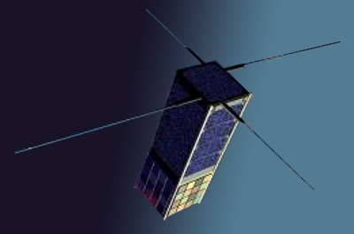

Figure Shields 1 [JPL]

NMTSat, ISX CubeSat, and STF-1 Sat presented clear earth observing objectives, with the remainder of the satellites focused on internal research or in-orbit prototyping for later satellites. Each one of these CubeSats are critically to the scientific community by building upon previous satellite research or paving the ground for new satellites. The continued interest in dedicated launch services by NASA and the Venture Class program will be showcased over the next years to days. In early Q1 of 2020, Virgin Orbit will hope to launch 10 CubeSats upon its LauncherOne Flight 2 (Educational Launch of Nanosatellites,3). LauncherOne will carry CACTUS-1, CAPE-3, ExoCube-2, INCA, MiTEE, PICS, PolarCube, Q-PACE, RadFXSat-2, TechEdSat-7 after being dropped from its modified 747-41R. Whether its from Electron, LauncherOne, or any rideshare programs, ELaNa and its Venture Class programs are sure to be ones to look up too.

References

1. “NASA ELaNa-19.” Rocket Lab, 16 Dec. 2018, [www.rocketlabusa.com/missions/completed-missions/elana-19/](http://www.rocketlabusa.com/missions/completed-missions/elana-19/).
2. Heiney, Anna. “ELaNa - Educational Launch of Nanosatellites.” NASA, NASA, 13 Apr. 2015, [www.nasa.gov/mission_pages/smallsats/elana/index.html](http://www.nasa.gov/mission_pages/smallsats/elana/index.html).
3. “Educational Launch of Nanosatellites.” Wikipedia, Wikimedia Foundation, 23 Dec. 2019, en.wikipedia.org/wiki/Educational_Launch_of_Nanosatellites.
4. “Gunter's Space Page.” Gunter's Space Page - Information on Spaceflight, Launch Vehicles and Satellites, space.skyrocket.de/index.html.
5. “Rocket Lab Press Kit”. Rocket Lab, 16 Dec.2018. https://www.rocketlabusa.com/assets/Uploads/NASA-ELANA19-Presskit-December2019.pdf